Today we inform you about following new themes:

Minimal Lubrication “DLC” 2
Features with respect to technology
and advantages on practical applications

New models and subclasses with DLC 3
Introduction at JIAM 2005

MX5214/BT250A/PL 3
manual BT - operations

WT169-08ACx356/UT/Y 4
Hemming of extreme small diameters

PL and TK adoption to MX 5
with brackets to be used temporary

EX3216H-A05/785-5x10 6
Extra wide seam of 15 mm (-5x10)

FS700, new optional feed dogs 7
2 additional types are now available,
with 1,25 and 2,5 mm tooth pitch

FS700, new optional chaining fingers 7
Shorter/thinner and thicker/longer chaining
finger as optional parts

W1500 , needle plates for tighter stitch 8
and possibility to reverse needle thread take-up

Best regards

U. Rabe

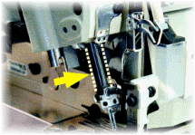

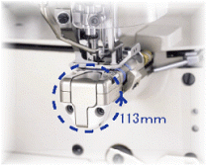

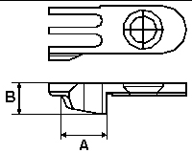

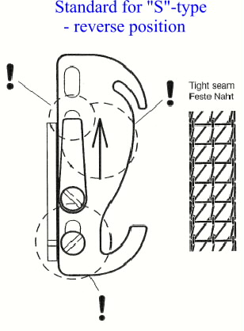

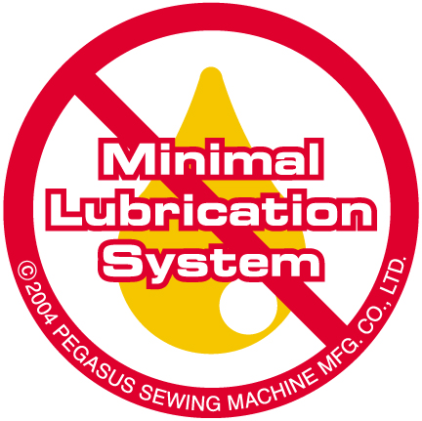
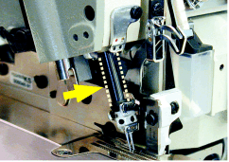


Minimal Lubrication

EX5214-M03/333-2x4, 2 – needle overlock machine for plain seaming

Minimal Lubrication is the preferred alternative to ”dry head”, due to high productivity, equal to standard EX-series.
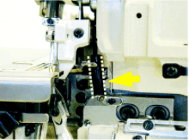
The high speed is achieved due to a special, very hard wearing and durable coating called “DLC”, Diamond Like Coating.

- Features and advantages

 Thanks to the special coating, the needle bar and the upper looper bar are very durable and need less oil supply (only ~10% of normal machine).
 It contributes to the oil spot prevention while keeping high productivity, like a standard machine.
 A conventional sewing speed of max. 8.500 rpm (1-needle machine) is achieved with minimal lubrication system.
 Especially big advantages on expensive fabric, like lingerie articles and similar.

 The other specifications and the
features on this machine are the same
as on the standard EX-series.

Showing the DLC-coating on the needle bar

Showing the DLC-coating on the upper looper

Further special parts used:

Special heat treatment of the

a, needle bar link.

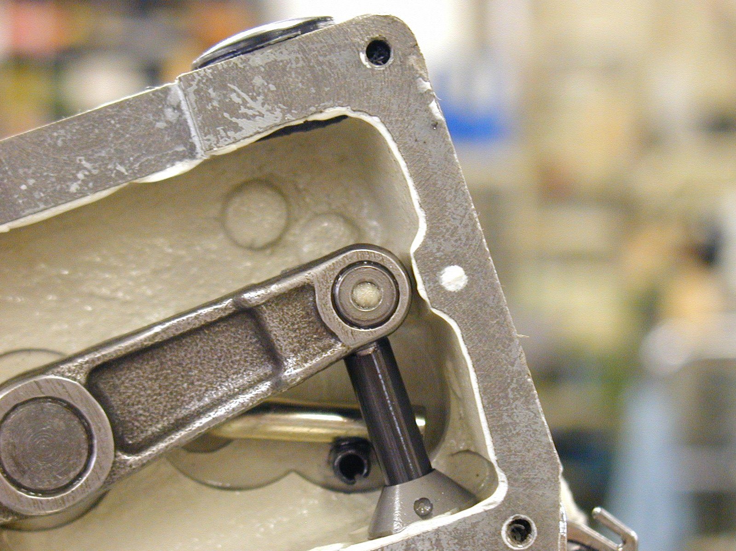

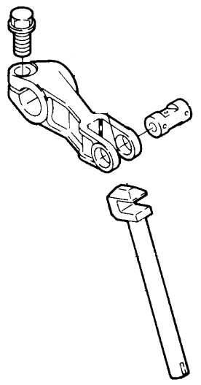

b, upper looper shaft link

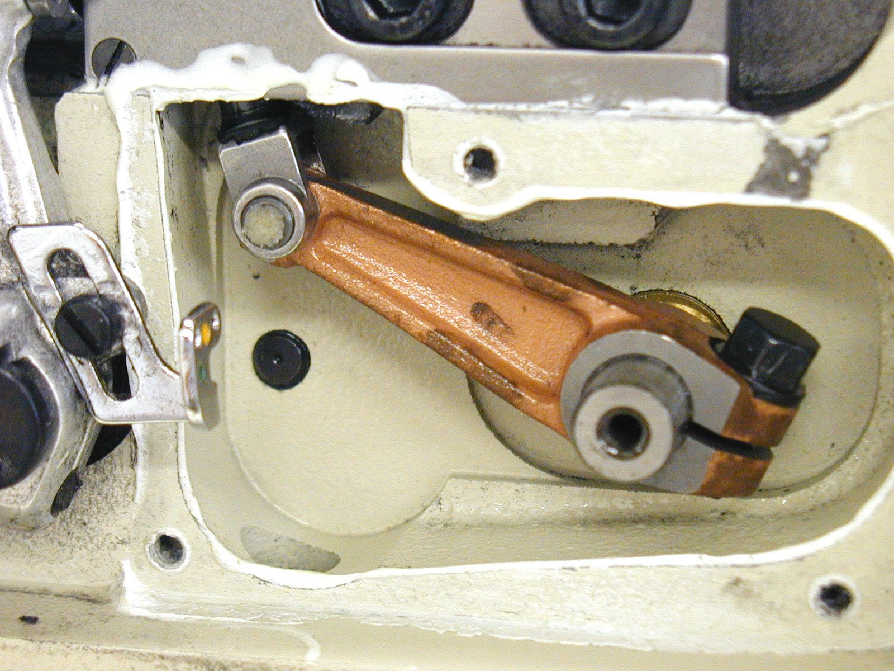

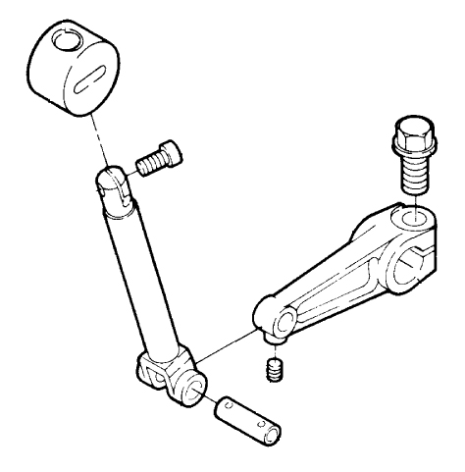

We keep the above model in our stock and are looking forward to receiving your order.


At Jiam 2005 further models with Minimal Lubrication “DLC” were introduced:

- EX5104-D-52D1/333-4/MC401 /GF121/Y7120
- EX5214-83BA/333-2x4/BL921/Y7118
- EX5214-M03/333-2x3/KS372/
SD200/PL181/Y7121

- EXT3244-A04/435K-5x3x4/TK122
/PL020/Y7124
- PHN-200

Technical specifications
of EX5214–M03 with DLC:

Needles: 2
Threads: 4
Seam width: 2x4 (6 mm)
Stitch length: 0,6 – 3,8 mm
Differential ratio: 0,7 – 2,0
Presser foot lift: 6 mm
Max. speed: 7500 rpm

Appendix: Flyer as PDF-File for
customers information


Manual BT-operations
MX5214-83/333-2x4/BT250A
/PL020/Y1852

2-needle high speed overlock machine for manual BT-operations on medium weight fabric, like T-shirts underwear and similar articles.
The Y1852 indicates, that this machine is without Pegasus BT-controller. The BT-functions, tension release and retractable chaining finger, are controlled by an electronic motor.

Photocell holder, depending on brand of photocell used, has to be added.

This gives the advantage of using the motor controller for the BT-functions as well. This is cost reducing and avoids using 2-nd controller for the BT.

We have to mention another advantage:
By using the retractable chaining finger, this machine is also very much suitable
for lighter weight fabric, without causing a bridge effect.

The above machines are available ex stock PE. We are looking forward to receiving your orders.



Hemming of extreme small diameters
WT169-08ACx356/UT/Y

The Series WT169 features interlock stitch machines feature the world’s smallest cylinder bed. With only a circumference of 113 mm, the machines are extremely suitable for hemming extra small tubular goods, such as sleeve openings of baby wear. Covering operations can also be performed.

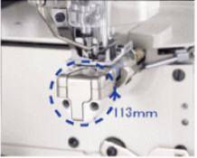

The very small arm of WT169 with a
circumference of tiny 113 mm.

This series is derived from the WT200 Series. In order to make the cylinder bed as small as possible, the belt feed mechanism has been introduced, so achieving the extremely small diameter cylinder bed with circumference of only 113 mm.

The machines feed the fabric using the variable top feed dog and bottom belt feed mechanisms. This way the presser foot pressure can be decreased. This feature reduces the occurrence of twists and waves formed on the fabric. Additionally to this feature, the machines do not now require bottom feed dogs that move up and down during sewing, which further contributes to flat finished seams.

This series is very effective in hemming babywear, such as sleeves as sleeves of romper suits, neck cut out, vests and similar garments with minimum circum-ference of only 130mm.

.

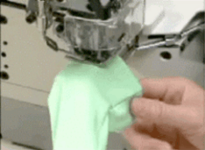

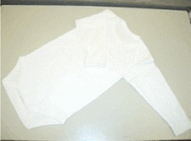

- FEATURES

  - Description
Interlock stitch machine with an extremely small cylinder bed

- Applications
Stitch type: 602, 605
Subclasses: -03 for covering
and -08 for hemming

- Functions
Variable top feed, with belt type bottom feed
Bottom feed: 2-row belt feed
Top feed: 4-row, top feed before and after the needle drop hole
Adjustable range of the amount of bottom feed: 0.5 ~ 3.2 mm
Bottom feed adjustment method: Micro adjustable type
Adjustable range of the amount of top feed: Vertical: 4 mm (standard up to 5mm)
Back and forth: 1 ~ 5 mm (standard)
Needle stroke: Stroke adjustment type (standard 31 mm)

- Performance

Maximum rpm: 4,000 rpm
Presser foot lift: 5.3 mm (-03)
4.8 mm (-08)
Needle space: 356, 364

screw 005154

Reference factories:
1, Petit Bateau, France and subsidiaries
in Morocco and Tunisia
2, Turkey

Machines are running well in production in above factories.

Bracket for PL and TK of MX

We use a bracket for PL and TK to
adopt the PL and TK of EX-series to MX-series. This is a temporary solution.

Bracket for PL of MX32/52

For MX32/52 we use the PL020 of EX-series and add above bracket 8C06410
and the screw 005154 to adopt the PL020 to MX-series.
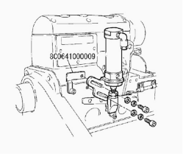

The bracket + screw are available ex PE.

Bracket for TK of MX32/52
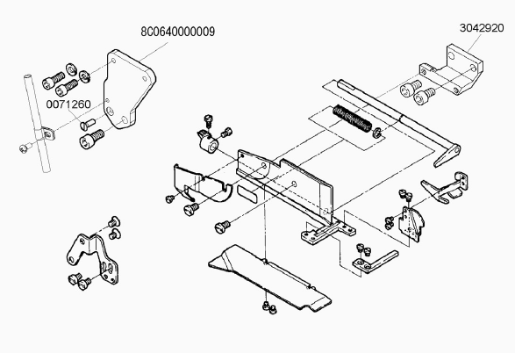

Following parts are additionally required:
1 x bracket 8C06400
3 x screw 007126
1 x bracket 304292

By using above items it is easy to adopt the TK of EX-series to MX-series.
This is a temporary solution.

EX3216H-A05/785-5x10/Y1697
Safety stitch machine EX3216H for extra wide seams of -5x10, i.e. 15 mm seam width.

Recently we have received some inquiries for extra wide seams of 15 mm on trousers or Stretch Jeans. This

machine offers the solution for such applications. It can handle a variety of different fabrics, like trouser fabric, skirts and Stretch Jeans fabric. Basically all fabrics which can fray easily and therefore require a wider seam for a stronger seam. Since the sewing capacity, of the upper looper movement, is not the same like a standard H-Version, it is possible to sew fabric with a max. thickness of ~ 5 mm. This means it must be made clear, that no thick cross seams, like lap seams, have to be sewn on Stretch Jeans. The ultra high lift of the H-version is used to obtain the large widthways movement of the upper looper; therefore the capacity high wise is restricted.
Please, keep the sewing capacity in mind, when you sell this machine, to avoid any conflict on heavy cross seams.



FS700, new optional
Part No. | Description | Applicable model | Pitch
236200B12509 | Main feed dog | FS701 | 1.25 mm
236201012509 | Differential feed dog | FS701 | 1.25 mm
3B0001012509 | Main feed dog | FS703A | 1.25 mm
3G0001012509 | Differential feed dog | FS703A | 1.25 mm
3B0002025009 | Main feed dog | FS703B | 2.5 mm
3G0002025009 | Differential feed dog | FS703B | 2.5 mm
available feed dogs

We would like to inform you that several kinds of feed dogs with different feed dog pitches have
been introduced in order to increase feeding efficiency and prevent the damage that occurs when the fabric is fed, according to diversified sewn products. 1,25 mm tooth pitch and 2,5 mm tooth pitch have been added to the standard product of 1,8 mm.

1,25 mm pitch feed dog

- Effective for light weight and soft fabrics that tend to be damaged when they are fed

- Two types of feed dogs have been introduced. One is for flat gauges of the FS700-G0, G1, G3 and G4, and another is for stepped gauge of the FS703A-G4, which has the 1mm stepped gauge.

2,5 mm pitch feed dog

- Feeding efficiency is increased when heavy weight fabrics, such as fleece are sewn,
- Feed dogs for the FS703B-G4 with a 1,5 mm stepped gauge have been introduced

Please, also refer to the TC-informations
TC-D0077 for above subject (PE-WebPage).

Further information

- on new presser foot shoes you find in TC-D0079
- one new fabric guide you see in TC-D0080

FS700, new optional
available chaining fingers

We would like to inform you that two types of needle plate chaining-off fingers have been introduced in order to respond to diversified sewing specifications.
They are different in length and thickness from the standard type.

1, Shorter finger

The needle thread can be released properly from the needle plate chaining-off finger, so the needle thread will be well tightened. This feature is effective for fine stitch length, and prevents seam jamming due to improper release of the needle thread.

2, Thicker finger

This finger prevents the needle thread from becoming tangled, and the looper thread is sufficiently supplied, even with woolly threads.

 | Length (A) | Thickness (B)
Standard | 7,1 mm | 2,75 mm
Short | 6,8 mm | 2,75 mm
Thick | 7,1 mm | 3,0 mm

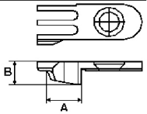

Short finger for 5.2 mm
not available
Short finger for 6.0 mm
236101A46009
Thick finger for 5,2 mm
236101C45209
Thick finger for 6,0 mm
236101C46009

You can find information in TC-D0081
on our WebPage, in the customer area.



W1500, needle plates for tighter stitch formation and possibility to reverse needle thread take-up

Under certain conditions, depending on fabric thickness and application, it is useful and/or necessary to have a tighter stitch formation. In such case, there is the possibility to change the needle plate type. In case the machine is equipped with “T”-type needle plate, 3,3 mm thickness, it can be changed to “B”-type needle plate with 2,8 mm thickness. After the change to “B”-type needle plate, most of the critical fabrics and applications can be covered and a good result is achieved, with respect to the desired seam quality.

Specification example:
W1562-oooXxxxxT
W1562-oooXxxxxS

You also can order new machines with the “S”-type needle plate, as this has shown to be less critical with respect to changing different types of fabric.

There is an additional possibility to change the needle thread take-up to the “reverse style” in conjunction with “S”-type needle plates. In this case the curve of the needle thread take-up is opposite and less needle thread is in the seam.

Please refer to pictures on the next page.

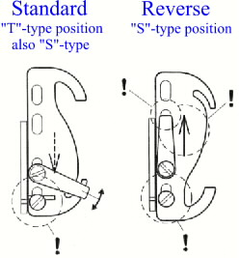

Comparison “Standard” and “Reverse” position of the needle thread take-up.

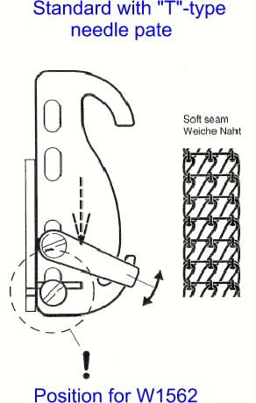

In standard position and with T-type needle plate, we achieve the soft seam.

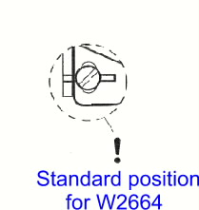

Showing standard height position of the thread take-up of W2664.

In reverse position and with S-type needle plate, we achieve the tight seam.

Ullrich Rabe
PEGASUS EUROPA GMBH

